Dominic Bumpus Agile and DFD Exercises
Dominic Bumpus
Trine University
SYS—5013-301
Dr. Kelly Wibbenmeyer
September 14, 2025

Exercise One Methodology Explanation:
For the Food2Go App the requirements were to have a way to browse restaurants, place an order, track an order, and provide customer feedback. A screen was made for each of these features in the prototype and a home page was made as well to house all these main features button links.
For styling, heavy focus was applied to making the app user friendly on a mobile device. Each restaurant in browsing mode shows its rating, delivery speed, restaurant type, and a button to view the menu. Order placement shows the menu item, description, price, and a quantity selection. Order tracking shows the driver, their estimated delivery time, and previous orders. Finally, the feedback page shows a 1-5 rating option, comment on the feedback, submit button, and the ability to see previous feedback as well as edit or delete said previous feedback.
Screenshots:
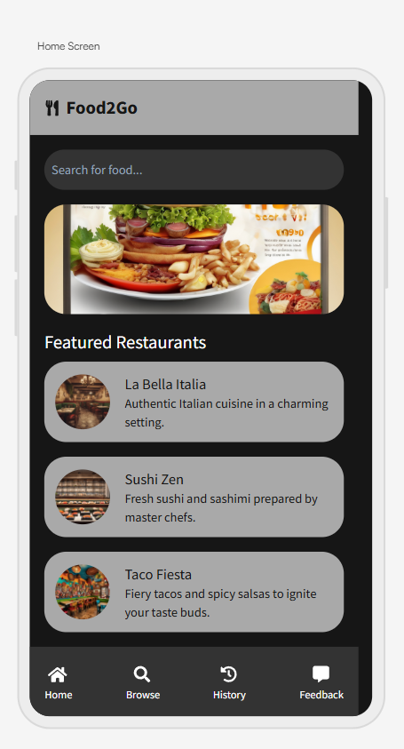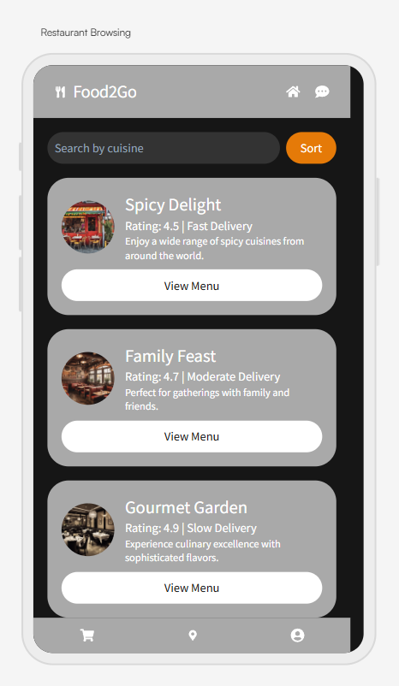
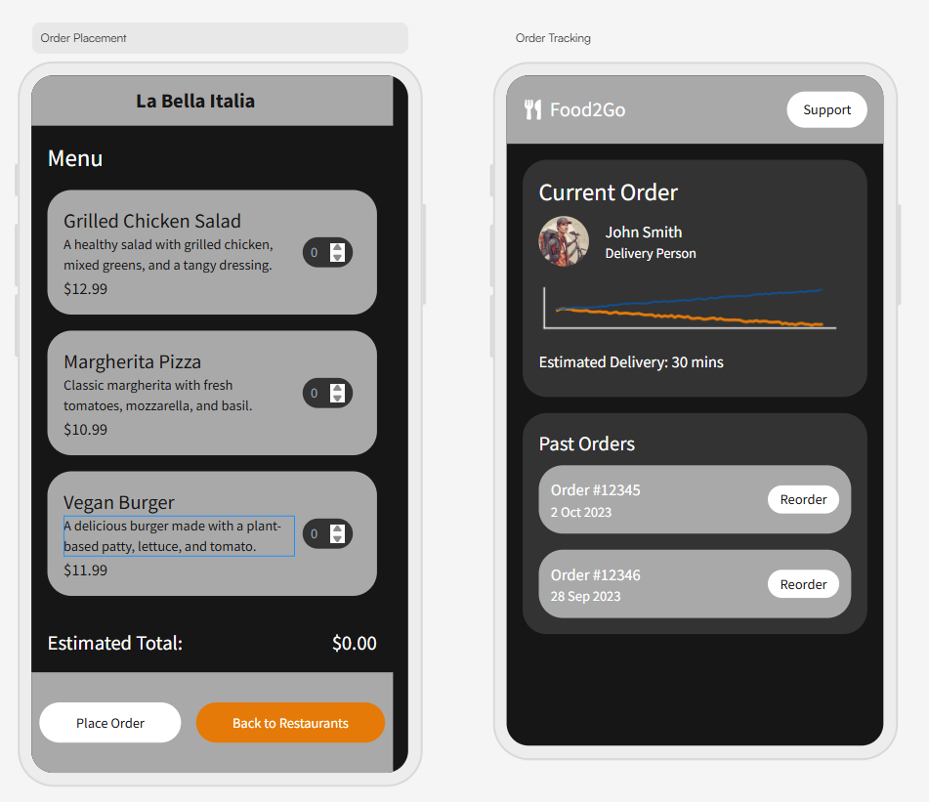
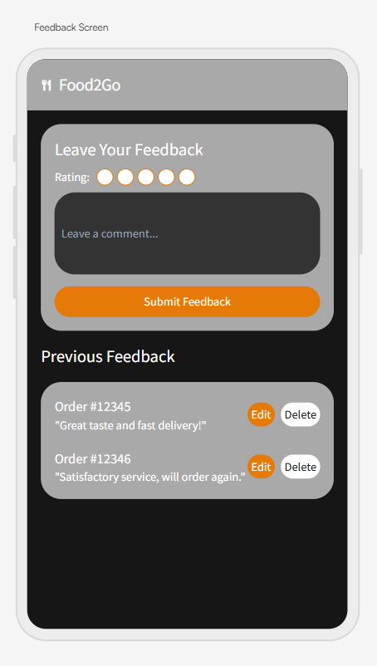
Exercise 2 DFD Explanation:
For the Data Flow Diagram for the university registration system, I decided to include four main stakeholders: The student, Registration, Accounting, and Enrollment. The diagram starts with the student sending a course registration request to registration, which then sends confirmation of the request back to the student. Registration then sends the course list to accounting. Accounting sends a bill for the courses to the student who then sends the payment for said bill. Once that is complete, Accounting sends a confirmation of payment to Enrollment. Enrollment then sends confirmation of enrollment to both registration and the student thus completing the registration process.
Screenshot:
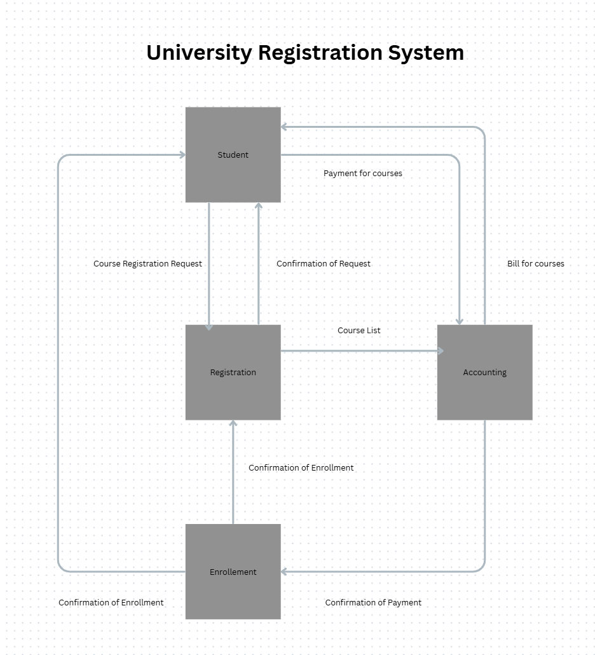
References:

Kendall, K. E., & Kendall, J. E. (2024). Systems Analysis & Design. Pearson.

